**SITEMAP:**

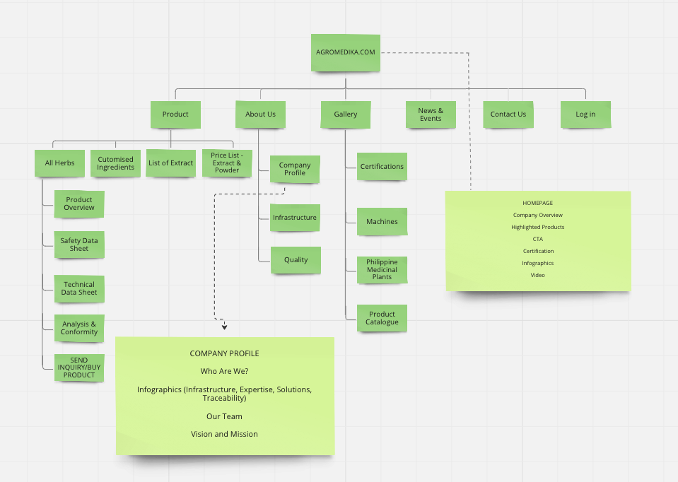<https://docs.google.com/spreadsheets/d/1fK24BKXtOf330QRM4UliwUKh6JMFaAUaf-4czVWsbWc/edit#gid=811404851>

* Search box next to Contact
* Cart icon on the upper right hand
* Chatbox at the bottom of each page (e.g. What’s App or Messenger)

**HOME:**

Site title: Agromedika by Herbanext Laboratories, Inc. - APPROVED,

Parent block:

MAIN TITLE: HERBAL EXTRACTS FROM THE PHILIPPINES

Subtitle: Manufacturer of standardized herbal extracts, herbal powder, essential oil, and nutraceutical ingredients

Block 1 - Short introduction of About Us (Block title with active link to About Us page)

Will contain a short introduction of Agromedika.

Block 2 - See Our Products (A short gallery of ingredients - priority to products That Herbanext want to push)

Block 3 - CTA: **Let’s Work Together**

DELETE: **Ready to grow your business?**

Update text to: Stock or custom formulations, single or multi-herb, we are experts in producing quality, safe, and standardised herbal extracts.

Change to Learn More **Let’s Work Together.** Make the block narrower and the font smaller ( a little bit more). This should link to **Contact Us.**

**Contact Form Page should be clean, crisp and business-like. The form should be the first thing we see especially on mobile view. Di na need mag-scroll.**

Block 4 - **Certified By:** Certification Logos

Delete **Guaranteed** **Certifications** and replace with **Certified By**

**So it should look like this on the centre:**

**Certified by**

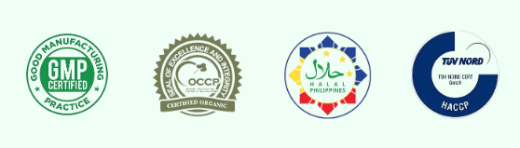

NO OTHER PHOTOS OTHER THAN CERTIFICATION LOGOS:

Block 5 - Infographics

20+ (years)

We are the Philippine’s first and only extraction and spray-drying facility, paving the way for the use of more potent herbal extracts over powdered forms.

3,500 (square meters) Our production plant is GMP-certified with toll and contract manufacturing capabilities for extracts, powder, nutraceuticals, and biopharmaceuticals.

250 (Herbal extracts)

We hold one of the largest in-site gene banks of medicinal and aromatic plants in the Philippines. Herbs produced in our farms and trusted farming communities are certified chemical-free.

20 (hectares)

Our organic farms in Bago City, Negros Occidental produces 30 different species of medicinal herbs that go straight into our factory for spray-dried extraction.

Footer - Short description of Manufacturing Plant, location map and email, essentials, social media links, highlighted links

**PRODUCTS:**

Banner image: Negros Occidental mountains (FOR NOW)

Banner text (moving):

1500 Philippine medicinal plants

250 species organically grown in our farms

120 species already verified for safety and efficacy

*Dropdown:*

1. **All Products** (All Products page should open to a display of icons in 5 rows, each row with 4 icons. Each icon should have the image of the herb with the common and scientific name below the image). When I click an icon, it should lead me to a product page that has 6 tabs or menu: **Product Overview**, **Safety Data Sheet**, **Technical Data Sheet**, **Product Data Sheet**, **Analysis and Conformity**, and **Buy Product**. The **Product Overview** (Literature) is the default tab.

Product Page Head Description:

**Agromediko supplies premium Philippine botanical and plant extracts in extract and powder forms for c**ompanies that manufacture herbal supplements, biopharma and nutraceuticals, functional food and beverages, organic personal care and cosmetic products, and animal feed. We also offer and pre-mix herbal extracts and customised solutions based on customer demand.

* Tabs 2 - 5 could look like this:

Sambong (Blumea Leaves)

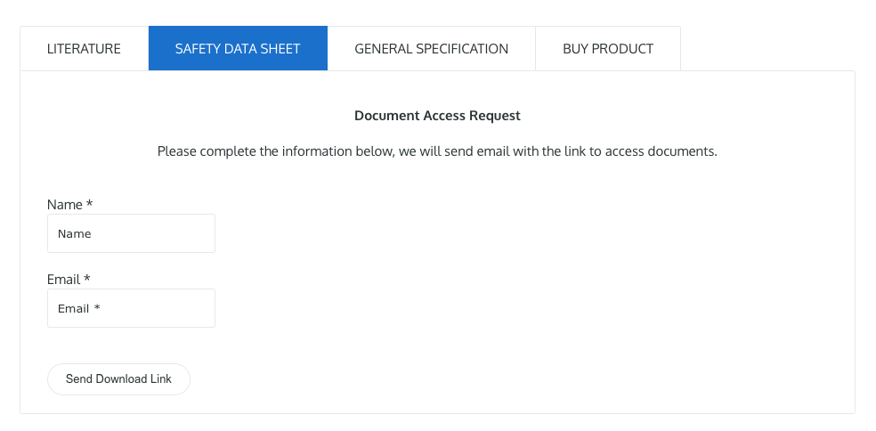

* Change General Specification to Product Data Sheet (Please make a sample product data sheet and safety data sheet using the brand design you made for the template with company name, address, telephone, and email on the header; certification logos on the side of the template ; and website address on the footer. There’s a product sheet sample at the last page. Make a watermarked template).
* Buy Product could look like this and should take me to the payment page:



* Change “Literature” to “Product Overview”

Should contain Image of the herb and some general info (Example for Sambong):

<https://docs.google.com/document/d/17W5Z4WcYcV6BP-mqRotw1DcoUmPZxznsyrr0yXaKN0s/edit>

* Can we also put a “Back to All Products” link at the bottom (on each product page)?

1. **Extract List**

A page with a simple table of the herbs. **See proposed table here, Sheet “All Products Page”:** [**https://docs.google.com/spreadsheets/d/1NqHJYIzM4xkaw3Ngqwdt0lcu2pW7oeERPJYJCDcTbYQ/edit#gid=2011107795**](https://docs.google.com/spreadsheets/d/1NqHJYIzM4xkaw3Ngqwdt0lcu2pW7oeERPJYJCDcTbYQ/edit#gid=2011107795)

Page Description:

**Agromediko supplies premium Philippine botanical and plant extracts in extract and powder forms for c**ompanies that manufacture herbal supplements, biopharma and nutraceuticals, organic personal care and cosmetic products, functional food and beverages, and animal feed. We also offer and pre-mix herbal extracts and customised solutions based on customer demand.

The hyperlink (underlined text below) should take me to the Product Overview tab.

At the bottom, there should be a click button that downloads this table in PDF format.

|  |  |  |  |  |  |  |
| --- | --- | --- | --- | --- | --- | --- |
| **No.** | **English Name** | **Philippine Name** | **Botanical Name** | **Botanical Part Used** | **Ratio Botanical** | **Indication** |
| 12. | Blumea Leaves | Sambong | Blumea balsamifera | Leaves | 10:01 | Rheumatism, stomachache, bladder and kidney ailments |
|  |  |  |  |  |  |  |
|  |  |  |  |  |  |  |

1. **Price List Extract**

See Price List Table Sample on the last pages of this document.

1. **Price List Powder**

See Price List Table Sample on the last pages of this document.

**ABOUT US**

1. **Company Profile**

Block 1 - Who are We? + 1 image

Agromedika herbal extracts are processed by Herbanext Laboratories. Our manufacturing plant was established in 2006 and expanded its operations in 2011 to become the Philippine’s first purpose-built extraction and modern spray-drying facility. Tapping into the Philippines’ vast botanical diversity, our GMP-accredited plant is now paving the way to an industry shift from the traditional use of powdered herbs to the use of more potent herbal extracts. Our mission is to share the medicinal and health benefits of Philippine herbs to the world.

Our expertise in herb extraction is complemented by GMP and HACCP-certified production lines for toll and contract manufacturing of functional foods, nutraceuticals, and herbal drugs; private labelling, laboratory services and product development.

Our manufacturing capabilities include: instant granulated beverages, loose teas and tea bags, tablets in strip foil, capsules in blisters, and herbal syrups, as well as personal use and cosmetic products.

**Block 2 - Infographics** - SHOULD BE SIMILAR LAYOUT TO THE ONE ON THE HOMEPAGE, NOT SEPARATE BLOCKS, just the header of the infographics below linked to the pages and blocks described below in italics.

|  |  |  |  |
| --- | --- | --- | --- |
| **Modern Infrastructure**  *(linked to Infrastructure Page)*  The Philippines’ first and only herbal extraction plant fully equipped with a state of the art production facility. We can produce _ tons of top quality extracts daily and effectively respond to bulk orders with ease. | **Reliable Expertise**  **(***inked to Team - Block 3)*  Agromedika’s product development team consists of experienced food technologists, pharmacists, chemists, and chemical engineers. We have over 15 years of experience in herbal extraction and product development. | **Customized Solutions**  **(***linked to Custom Ingredients Page)*  Our ability to control raw materials and ingredient manufacturing processes allow us to deliver innovative and customized solutions to suit customer demand. | **Organic and Fully Traceable**  **(***linked to Organic Farms -Block 3, Infrastructure Page)*  Herbs produced in these farms are certified to be chemical-free by the Organic Certification Council of the Philippines. |

**Block 3 - Our Team**

**Block 4** - **Vision and Mission (H1)**

**Vision (H2):**

Become the leading producer of Philippine extracts and herbal ingredients through science-based formulas.

**Mission (H2): - I revised this to just one paragraph, para mas compact for mobile viewing.**

Together with our partner farmers and farming communities, AgroMEdika will always strive to improve the quality of raw material through greener farming techniques. We shall harness the healing power of Philippine medicinal herbs through evidence-based research and collaboration, and develop a portfolio of effective, affordable and safe natural ingredients with modern technology. We will create a socially and environmentally responsible supply chain that protects Philippine biodiversity while contributing to a holistic concept of health and well-being for all peoples of the world.

1. **Infrastructure (Page Title)**

**Block 1: Our Production Facility (H1)**

**TEXT:**

*Description of Agromedika’s modern facilities, technology, international standard;*

*Processing capacity - X tons per month*

*A short description of extract production*

*Control and monitoring, staff expertise*

*Contamination prevention*

We have a dedicated research facility for the scale-up production of pharmaceutical-grade medicinal plant extracts — a first in the Philippines.

**Block 2: Research and Development (H2)**

*Additional short description of R&D Department and its capabilities*

**Block 3: Organic Farms (H2)**

We have over 20 hectares of organic farms in Bago City, Negros Occidental, producing **over 30 different species of medicinal herbal extracts.** Herbs produced in our farms and partner farms are certified chemical-free by the Organic Certification Council of the Philippines. We operate the largest in-situ gene bank of medicinal and aromatic plants in the country with over 250 species in our collection.

From these nucleus farms and nurseries, Agromedika supplies traceable planting materials to marginalized farming communities for its contract farming operations. The cultivation of medicinal herbs generate sustainable livelihood for small farmers in Negros islands. Contract farming of medicinal herbs generates a sustainable livelihood for the upland communities.

**IMAGES** *(Gallery)*

*Factory Photos*

*Laboratory Photos*

*Farm Photos*

**3. Quality Control and Assurance (H1)**

**Quality Control (H1)**

The company maintains an advanced pharmaceutical quality control laboratory with in-house capabilities for HPLC, HPTLC, and UV-Vis analysis.

*Short description of pharmaceutical guarantee, compliance, international standards testing tools, process monitoring*

*Examples of testing tools (will have to confirm with Herbanext)*

*1. HPLC (High Performance Liquid Chromatography)*

*2. Spectrophotometer UV-Vis*

*3. TLC Densitometer*

*4. Photostability Chamber*

*5. Laminar Air Flow*

*6. Tablet Hardness Tester*

*7. Viscometer*

*8. Autoclave*

*9. Moisture Analyzer*

*10. High Performance Microscope*

*11. Disintegration Tester*

**Quality Assurance (H2)**

Our clients are assured of the quality of our products by our commitment to:

* Work with farmers to supply us with the highest quality herbs.
* Maintain our own research farm for developing greener farming technologies.
* Carefully evaluate each ingredient we use and every supplier we work with.
* Manufacture products that have proven efficacy and are free of artificial substances and potentially harmful ingredients.
* Invest in our own manufacturing facilities, in our people, and in science to attain and surpass our quality standards.

**GALLERY**

**Dropdown:**

**1. Certificates (a page for PDF, images of certificates or links)**

Could have a side menu like this:

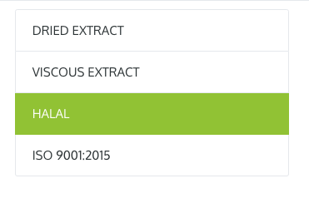

**FDA**

**GMP**

**OCCP**

**HALAL**

**HACCP**

**2. Brochures (a page for PDF downloadables or viewing or links)**

In side menu as above:

**Machine Catalogue**

**Philippine Medicinal Plants**

**Product Catalogue**

**Product Data Sheet (Sample Only)**

| **Common name** | **:** | **Blumea Leaves Dry Extract** |
| --- | --- | --- |
| Botanical name | **:** | Blumea balsamifera |
| Local name | **:** | Sambong |
| Raw material | **:** | Leaves, dried |
| Ratio plant to extract | **:** | 10 kg raw material yield 1 kg product |
| Identification | **:** |  |
| Active component | **:** |  |
| Extraction solvent | **:** | Ethanol |
| Excipients | **:** | Maltodextrin |
| Preservative | **:** | Not applicable |
| Shape | **:** | Granule |
| Size | **:** | 70% passed mesh 12 |
| Colour | **:** | Brownish gray |
| Odor | **:** | Aromatic |
| Taste | **:** | Bitter |
| Moisture content | **:** | Less than 5% |
| Packing detail | **:** | 1-5 kg (or request) |
| Certification | **:** |  |
| Halal status | **:** | Philippine certified |
| Country of Origin | **:** | Philippines |
| Production | **:** | By 70% ethanol solvent - percolator system extraction |
| Drying | **:** | By vacuum belt dryer |
| Shelf life | **:** | At least 4 years from manufacturing date if kept sealed and away from sunlight |
| Storage condition | **:** | Keep under cool and dry storage temperature in an airtight foil pouch. Use up as soon as possible and seal back when necessary. |
| Indication | **:** | Rheumatism, stomach ache, astringent, anthelmintic, carminative, expectorant, influenza |

**Microbiological Test Benchmark:**

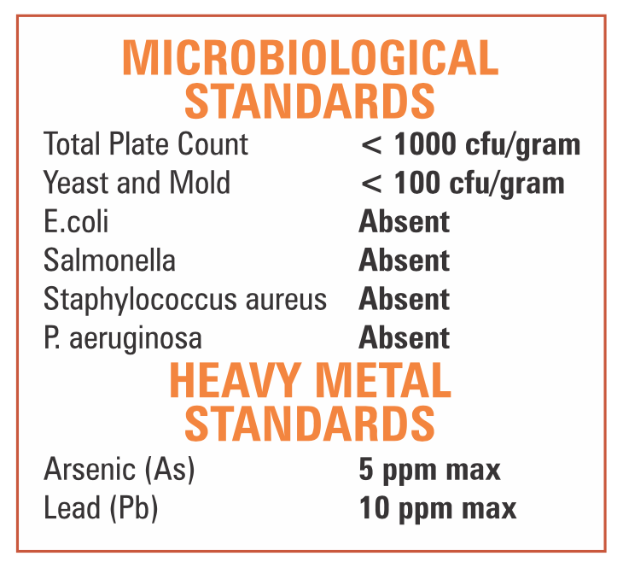

This information is valid when issued by Agromedika or Herbanext Laboratories.

**Safety Data Sheet (Sample Only)**

|  |  |
| --- | --- |
| **1. Identification** |  |
| *Identification of Product* |  |
| Product Name : | Blumea Leaves P.E |
| Local Name : | Daun Sembung |
| Plant species : | ***Blumea balsamifera*** |
| Indication : | Rheumatism, stomachache, astringent, anthelmintic, carminative, expectorant, influenza |
| *Identification of Company* |  |
| Company Name : | Agromedika |
|  | Bago City, Negros Occidental, Philippines |
| Company Telephone : | +63 34 732-8106 |
| **2. Hazards Identification** |  |
| This product is not considered to be hazardous. | |
| **3. Information of Ingredients** |  |
| Blumeae Folium Extract : | 85% |
| Maltodextrine : | 15% |
| **4. First Aid Measures** |  |
| Inhalation : | Remove individual to fresh air |
| Skin Contact : | Flush skin with water. Call a physician if irritation develops |
| Eye Contact : | Flush eye with water. Call a physician if irritation develops |
| **5. Fire Fighting Measures** |  |
| Extinguishing media : | Carbon dioxide, dry chemicals, foam, and water spray |
| **6. Accidental Release Measures** |  |
| Personal precautions : | Use personal protective equipment |
| Environmental precautions : | No special environmental precautions required |
| Methods for cleaning up : | Sweep up and flush with water |
| **7. Handling and storage** |  |
| Store in sealed containers under normal cool, dry warehouse conditions. | |
| **8. Exposure Control / Personal Protection** | |
| Personal protection : | None under normal conditions |
| Respiratory protection : | Not applicable |
| Eye protection : | Safety glasses may be desirable when dumping bags |
| Hand protection : | Heat protection above 45° C |

|  |  |
| --- | --- |
| **9. Physical and Chemical Properties** | |
| *Physical Properties* |  |
| Appearance : | Granule |
| Color : | Brownish Gray |
| Odor : | Aromatic |
| Taste : | Bitter |
| Mesh Size : | 70 % pass mesh 12 |
| Loss on Drying : | 5.0 % max. |
| *Chemical Properties* |  |
| Heavy Metal: |  |
| Arsenic (As) : | 5 ppm max |
| Lead (Pb) : | 10 ppm max |
| **10. Stability and Reactivity** |  |
| Stability and Reactivity Summary : | Stable under normal conditions |
| **11. Toxicological Data** |  |
| Human experience : | No toxic effect in normal use |
| **12. Ecological Information** |  |
| No significant environmental hazard or adverse effect from human exposure resulting from the accidental release of this material is anticipated. | |
|
| **13. Disposal Advice** |  |
| No special disposal method required, except that it be in accordance with current local authority regulations | |
| **14. Transport Information** |  |
| Not applicable | |
| **15. Regulation Information** |  |
| Labelling according to NADFC guidelines. | |
| Observe the general safety regulations when handling chemicals | |
| **16. Further Information** |  |
| These statements are based on our present knowledge and are meant to describe our product in regards to our safety regulations. Therefore they are not meant to assure special characteristics. Existing laws and regulations have to be noted by the consignee himself. Since the conditions of use are beyond the control of our company, it is the responsibility of the user to determine the conditions of safe uses of this product. The information in this sheet does not represent analytical specifications, for which please refer to our technical data sheet. | |
|
|
|

This information is valid when issued by Agromedika or Herbanext Laboratories.

**Price List for Herbal Extract (Local and Export)- SAMPLE SHEET**

|  |  |  |  |  |
| --- | --- | --- | --- | --- |
| **No.** | **Herbal Extract** | **Quantity** | **Local Price (PHP)** | **International Price (USD)** |
| 1 | Asthma weed (Tawatawa) | 1 kg | 2,325 | 45 |
| 2 | Batuan | 1 kg |  |  |
| 3 | Bitter Gourd (Ampalaya) - leaves | 1 kg | 1,786 | 35 |
| 4 | Black currant tree (Bignay) | 1 kg |  |  |
| 5 | Black mulberry | 1 kg |  |  |
| 6 | Cat's Whiskers | 1 kg | 4,142 | 80 |
| 7 | Cayenne pepper (Sili) | 1 kg |  |  |
| 8 | Centella/Gotu Kola | 1 kg | 2,178 | 43 |
| 9 | Citronella | 1 kg |  |  |
| 10 | Elemi | 1 kg |  |  |
| 11 | Five-leaved Chaste Tree (Lagundi) | 1 kg |  |  |
| 12 | Forest Tree (Tsaang gubat) | 1 kg |  |  |
| 13 | Ginger | 1 kg | 6,070 | 118 |
| 14 | Holy Basil | 1 kg |  |  |
| 15 | Jute Mallow (Saluyot) | 1 kg |  |  |
| 16 | King of Bitters (Serpentina) | 1 kg | 2,357 | 46 |
| 17 | Lemongrass | 1 kg |  |  |
| 18 | Mangosteen | 1 kg | 1,714 | 34 |
| 19 | Mexican oregano | 1 kg |  |  |
| 20 | Moringa (Malunggay) | 1 kg | 1,821 | 36 |
| 21 | Neem | 1 kg |  |  |
| 22 | Ngai camphor (Sambong) | 1 kg | 3,035 | 59 |
| 23 | Noni | 1 kg | 1,420 | 33 |
| 24 | Orange (Dalandan) | 1 kg |  |  |
| 25 | Painted Nettle (Mayana) | 1 kg |  |  |
| 26 | Queen's Crape Myrthle (Banaba) | 1 kg |  |  |
| 27 | Roselle | 1 kg |  |  |
| 28 | Seed under leaf (Sampasampalokan) | 1 kg | 2,357 | 46 |
| 29 | Turmeric | 1 kg |  |  |
| 30 | Tamanue | 1 kg |  |  |

This information is valid when issued by Agromedika or Herbanext Laboratories.

**Price List for Herbal Powder (Local and Export)**

|  |  |  |  |  |
| --- | --- | --- | --- | --- |
| **No.** | **Herbal Powder** | **Quantity** | **Local Price (PHP)** | **International Price (USD)** |
| 1 | Asthma weed (Tawatawa) | 1 kg |  |  |
| 2 | Batuan | 1 kg |  |  |
| 3 | Bitter Gourd (Ampalaya) | 1 kg |  |  |
| 4 | Black currant tree (Bignay) | 1 kg |  |  |
| 5 | Black mulberry | 1 kg |  |  |
| 6 | Cat's Whiskers | 1 kg |  |  |
| 7 | Cayenne pepper (Sili) | 1 kg |  |  |
| 8 | Centella/Gotu Kola | 1 kg |  |  |
| 9 | Citronella | 1 kg |  |  |
| 10 | Elemi | 1 kg |  |  |
| 11 | Five-leaved Chaste Tree (Lagundi) | 1 kg |  |  |
| 12 | Forest Tree (Tsaang gubat) | 1 kg |  |  |
| 13 | Ginger | 1 kg |  |  |
| 14 | Holy Basil | 1 kg |  |  |
| 15 | Jute Mallow (Saluyot) | 1 kg |  |  |
| 16 | King of Bitters (Serpentina) | 1 kg |  |  |
| 17 | Lemongrass | 1 kg |  |  |
| 18 | Mangosteen | 1 kg |  |  |
| 19 | Mexican oregano | 1 kg |  |  |
| 20 | Moringa (Malunggay) | 1 kg |  |  |
| 21 | Neem | 1 kg |  |  |
| 22 | Ngai camphor (Sambong) | 1 kg |  |  |
| 23 | Noni | 1 kg |  |  |
| 24 | Orange (Dalandan) | 1 kg |  |  |
| 25 | Painted Nettle (Mayana) | 1 kg |  |  |
| 26 | Queen's Crape Myrthle (Banaba) | 1 kg |  |  |
| 27 | Roselle | 1 kg |  |  |
| 28 | Seed under leaf (Sampasampalokan) | 1 kg |  |  |
| 29 | Turmeric | 1 kg |  |  |
| 30 | Tamanue | 1 kg |  |  |

This information is valid when issued by Agromedika or Herbanext Laboratories.